There are Two users:-

1. Admin user “Varun”. Varun can perform delete, update, add operations.
2. Normal user ”Sanjay”. Sanjay can perform only Add operation & will get access denied upon attempting Update, Delete operation.

Login with Admin user “Varun”

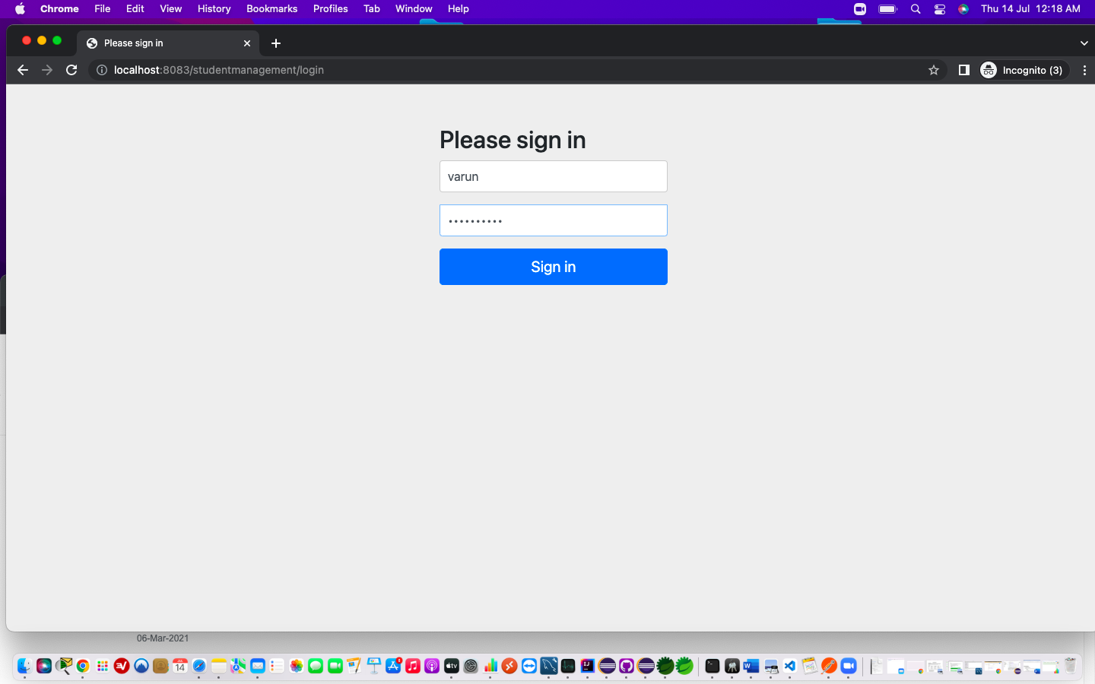

Login Successful with Varun.

Admin user “Varun” can perform Delete on student “sraetr”

Sraetr has been deleted.

Varun can Update fields of student “test”

“Test” student updated successfully.

Varun can add new student “Ajit”

“Ajit” added successfully

Logout from admin user “Varun”

Now Login with user “Sanjay”

Login Successful with “Sanjay”

Sanjay can add student Manish Shete

Manish Shete added successfully.

Sanjay attempts to Delete “Manish Shete”

# Sanjay cannot Delete Manish Shete and getting HTTP Status 403 - Access is denied

# Sanjay cannot Update Manish Shete and getting HTTP Status 403 - Access is denied

